Unit 4: Pushing the Limits
Section 2: Into the Snake Pit
Gerald Malcolm Durrell, OBE (7 January 1925 – 30 January 1995) was a British naturalist, zookeeper, conservationist, author, and television presenter. He founded the Durrell Wildlife Conservation Trust and the Jersey Zoo on the Channel Island of Jersey in 1959. His memoirs of his family's years living in Greece were adapted into the television series The Durrells, and he wrote a number of books about his life as an animal collector and enthusiast, the most famous being My Family and Other Animals. He was the youngest brother of novelist Lawrence Durrell.

Gerald Durrell in Askania Nova, 1985
Born | Gerald Malcolm Durrell  7 January 1925  Jamshedpur, British India
Died | 30 January 1995 (aged 70)  Saint Helier, Jersey
Known for | Founder of Jersey Zoo, television presenter, conservationist
Spouse(s) | - Jacquie Durrell (m. 1951 – div. 1979)  - Lee Durrell (m. 1979)
Parent(s) | Lawrence Samuel Durrell and Louisa Durrell
Family | Lawrence (brother), Margaret (sister), Leslie Durrell (brother)

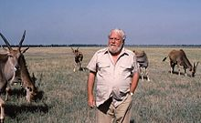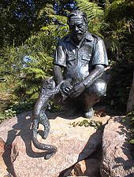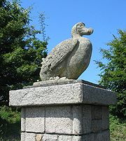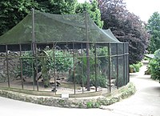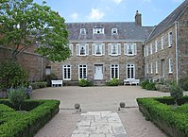

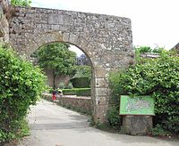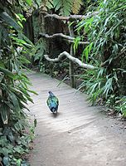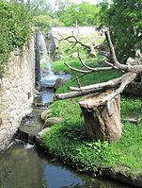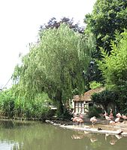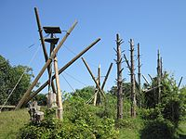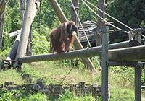

Many years ago I went to Kenya and one of the things arranged for us was a visit to the Kenya Herpetarium. As soon as we entered the gates I began to feel uneasy and this fear increased as we went around each pit and glass enclosure .When the director picked up a snake casually and stretched his arms towards me, I almost turned and ran. The fact that I was familiar with animals and felt a strong empathy with them, the fact that I knew that the snake was of the harmless variety, did not make my herpetophobia any less.

The narrator told him that in all the months he had spent in the forest he had seen exactly five snakes, and these had run away so fast that he had been unable to capture them. He also told him that the majority of snakes were extremely easy to capture, if you kept your head and knew your snake and its habits. The Irishman was so delighted at the thought of all those specimens he had found for the narrator, moreover he had been boasting about the narrator to his friends and the narrator did not want to disappoint him. The eighth one was the narrator himself. He was not excited because he was the one who had to enter the snake pit on his own. He was anxious. First, he tried to make the lighting in the pit an issue and tried to back out gracefully. When that failed, he said that his trousers and shoes were too thin and not suitable for the task at hand.
He means that it was not necessary for him to have agreed to go snake catching in the dangerous pit that night. It was both foolish and dangerous. By taking such a risk, he had voluntarily exposed himself to trouble and danger. As a collector, one must be careful about the extent to which he is willing to risk danger. The narrator is criticizing himself for having been stupid enough to enter the deadly snake pit in the way he did. It is ironical that before they begin the ordeal, they wait for MacTootle’s brother and sister-in-law to join them as they might never get another chance to see a man catching snakes. But after having put the narrator through the whole ordeal, MacTootle says that his brother didn’t have the required ‘courage’ to watch the ordeal. All along, they are unaware of the narrator’s miserable plight.

The task was more difficult because of two reasons: There was not enough light at the bottom of the pit.The pit was crawling with young Gaboon vipers, one of the deadliest snakes in the world that were very sluggish during daytime, but at night when they woke up and hunted for their food, they could be unpleasantly quick.No, the narrator was not relieved because he had hoped that if he did not have suitable clothes, he could have opted out of the snake-hunt using that excuse. Gaboon vipers are one of the deadliest snakes in the world. They are very sluggish during daytime, but at night when they wake up and hunt for food, they can be unpleasantly quick. The narrator was going into the pit at night. The vipers were beautifully marked with an intricate pattern of brown, silver-pink and cream blotches, and when they remained still, this colouration made them extremely hard to spot in the pit; they just melted into the background.

